Rossmoyne Senior High School

Semester One Examination, 2014

Question/Answer Booklet

MATHEMATICS 2C
SOLUTIONS

Section One:

Calculator-free

Student Number: In figures

In words

Your name

Time allowed for this section
Reading time before commencing work: five minutes
Working time for this section: fifty minutes

Materials required/recommended for this section

To be provided by the supervisor
This Question/Answer Booklet
Formula Sheet

To be provided by the candidate
Standard items: pens, pencils, pencil sharpener, eraser, correction fluid/tape, ruler, highlighters

Special items: nil

Important note to candidates

No other items may be used in this section of the examination. It is your responsibility to ensure that you do not have any unauthorised notes or other items of a non-personal nature in the examination room. If you have any unauthorised material with you, hand it to the supervisor before reading any further.

Structure of this paper

Section | Number of questions available | Number of questions to be answered | Working time (minutes) | Marks available | Percentage of exam
Section One:  Calculator-free | 6 | 6 | 50 | 50 | 33⅓
Section Two:  Calculator-assumed | 12 | 12 | 100 | 100 | 66⅔
 |  |  | Total | 150 | 100

Instructions to candidates

- The rules for the conduct of Western Australian external examinations are detailed in the Year 12 Information Handbook 2013. Sitting this examination implies that you agree to abide by these rules.

- Write your answers in the spaces provided in this Question/Answer Booklet. Spare pages are included at the end of this booklet. They can be used for planning your responses and/or as additional space if required to continue an answer.
- Planning: If you use the spare pages for planning, indicate this clearly at the top of the page.
- Continuing an answer: If you need to use the space to continue an answer, indicate in the original answer space where the answer is continued, i.e. give the page number. Fill in the number of the question(s) that you are continuing to answer at the top of the page.

- Show all your working clearly. Your working should be in sufficient detail to allow your answers to be checked readily and for marks to be awarded for reasoning. Incorrect answers given without supporting reasoning cannot be allocated any marks. For any question or part question worth more than two marks, valid working or justification is required to receive full marks. If you repeat an answer to any question, ensure that you cancel the answer you do not wish to have marked.

- It is recommended that you do not use pencil, except in diagrams.

Section One: Calculator-free (50 Marks)
This section has six (6) questions. Answer all questions. Write your answers in the spaces provided.

Working time for this section is 50 minutes.

Question 1 (4 marks)
(a) A network is comprised of the four vertices P, Q, R and S. The distances between the four vertices are shown in the table below in metres.

 | P | Q | R | S
P | 0 | 6 | 5 | 4
Q | 6 | 0 | 4 | 5
R | 5 | 4 | 0 | 5
S | 4 | 5 | 5 | 0

Determine the length of the minimum spanning tree for this network. (2 marks)

PS 4
QS 5
QR 4

Minimum length 13 m.

(b) A different network is shown below. Highlight the minimum spanning tree of this network.
(2 marks)
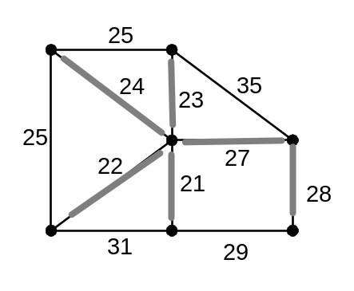

Question 2 (9 marks)
(a) Write the number 12 500 000 using scientific notation. (1 mark)

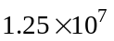

(b) Determine 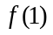 given that 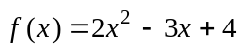. (1 mark)

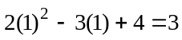

(c) Use set notation to describe the shaded region in the Venn diagram below. (1 mark)
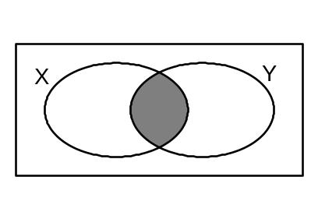
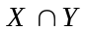

(d) Determine the gradient of the line with equation 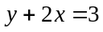. (1 mark)

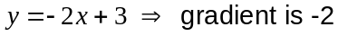

(e) Solve 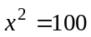. (1 mark)

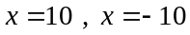

(f) Factorise 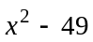. (1 mark)
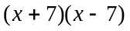

(g) Evaluate 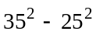. (1 mark)

(h) Solve 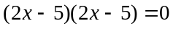. (1 mark)

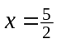

(i) Given 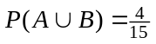, determine 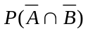. (1 mark)
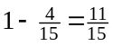

Question 3 (14 marks)
(a) Solve the equation 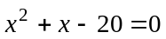. (2 marks)
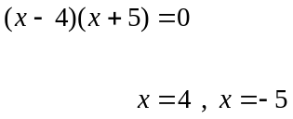

(b) A cube with faces marked A, B, C, D, E and F is thrown 24 times. If each letter has an equal chance of landing uppermost, determine how many times it is expected to land with either the C or D uppermost. (2 marks)
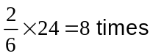

(c) Determine the interest paid on $2 000 invested at 5% per annum simple interest for six months. (2 marks)
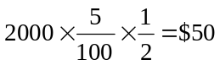

(d) On the axis below, sketch the graph of a parabola that has a-intercept at (0, -2) and a turning point at (1, -1). (2 marks)
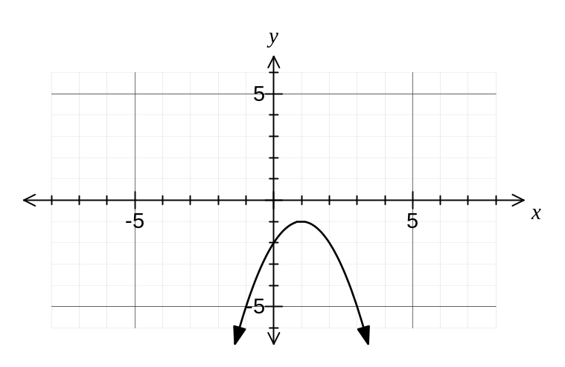

(e) A young person can take out a loan of $20 000 for two years with interest of 11% pa compounded monthly. They can repay the loan using one of the following options:

A: Make a single repayment of the loan amount plus interest at the end of the two years.

B: Make 24 equal monthly repayments so that after two years the loan is fully repaid.

Explain which of the two options you would recommend to the young person in order to minimise the amount of interest they have to pay. (2 marks)

Option B, as each month the amount of the loan will decrease, resulting in less interest payable each month.

(f) The lengths, in metres, of sixty alligators in a breeding program are shown below in ascending order.

119, 125, 137, 140, 140, 141, 144, 148, 151, 152, 154, 154, 155, 156, 158, 158, 160, 162, 162, 162, 163, 165, 166, 167, 168, 169, 169, 169, 170, 170, 170, 171, 172, 173, 174, 174, 177, 177, 178, 179, 179, 181, 181, 182, 183, 184, 186, 187, 187, 187, 188, 189, 193, 193, 194, 196, 201, 208, 208, 210

A researcher requires the data to be grouped in equal sized class intervals so that a histogram may be drawn. What class intervals would be appropriate for this data?
Do not group the data. (2 marks)
Require about six to twelve classes, with suitable boundaries. For example:
110 - 119
120 - 129
....
210 - 219

(g) Describe the spread of the data displayed in the graph below, which shows the number of emergency calls an electrical contractor received per day over a 23 day period. (2 marks)
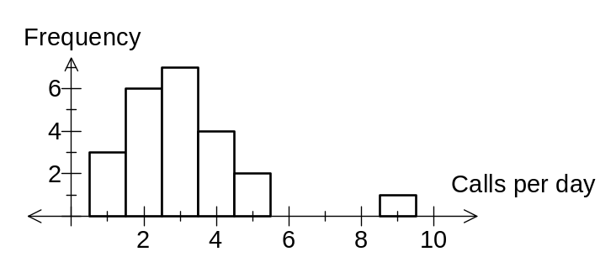
Data is clustered between 1 and 5 calls per day with an outlier of 9 calls on one day.

Question 4 (9 marks)
A cycling event was open to teams consisting of one male and one female competitor. The scatterplot below shows the times, rounded to the nearest minute, taken by each pair of competitors in the event.

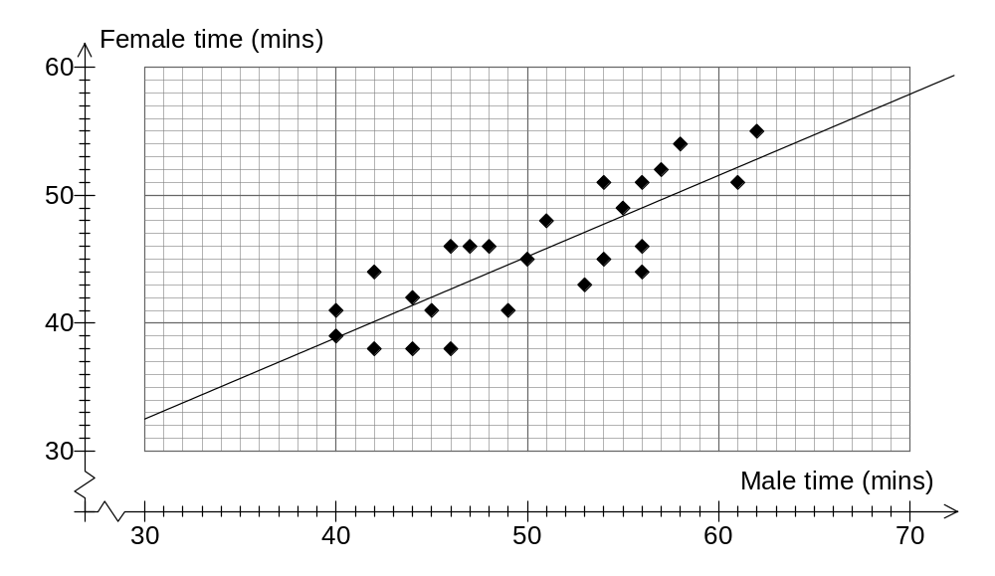

(a) The male competitor in one team took 50 minutes. How long did his female team mate take? (1 mark)
45 minutes

(b) How many teams had a total time of 110 minutes or more? (1 mark)

3 teams

(c) The competition was won by the team with the smallest total time of both cyclists. What was the winning time? (1 mark)
79 minutes

(d) Draw a trend line on the scatterplot by eye. (2 marks)

(e) Use your trend line to predict the time taken, to the nearest minute, by the female team mate of a male who took

(i) 52 minutes (1 mark)
46 minutes

(ii) 65 minutes (1 mark)
55 minutes

(f) Which prediction in (e) do you consider to be the most reliable? Explain your answer.
(2 marks)
The first prediction of 46 minutes, as it involves interpolation whereas the second involves extrapolation and so is unreliable.

Question 5 (6 marks)
(a) State the coordinates of the -intercept of the graph of 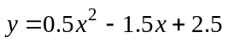. (1 mark)

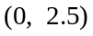

(b) A function is defined as 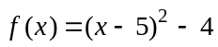.

(i) State the coordinates of the turning point of . (2 mark)

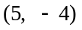

(ii) Is the turning point of a minimum or maximum? Justify your answer.
(1 mark)
Minimum. When is expanded the 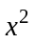 coefficient is positive.

(c) Determine the equation of the line of symmetry of the graph of 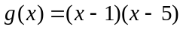.
(2 marks)
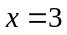

(Line of symmetry is midway between roots at 1 and 5)

Question 6 (8 marks)
Write the letter of the graph of each linear or quadratic function in the space provided.

Function | 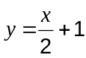 | 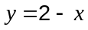 | 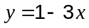 | 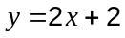
Graph | C | B | F | G
Function | 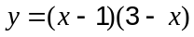 | 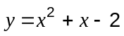 | 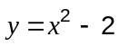 | 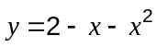
Graph | H | E | D | A
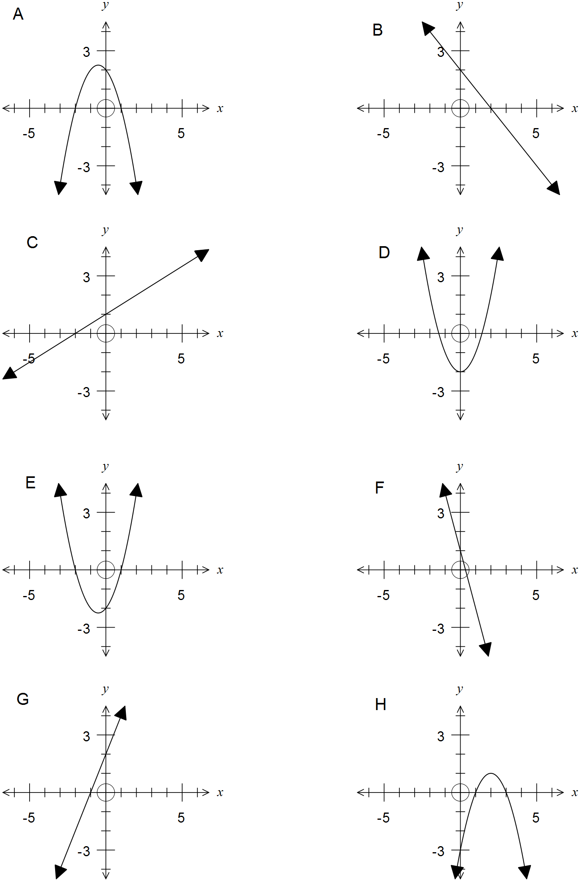

This examination paper may be freely copied, or communicated on an intranet, for non-commercial purposes within educational institutes that have purchased the paper from WA Examination Papers provided that WA Examination Papers is acknowledged as the copyright owner. Teachers within Rossmoyne Senior High School may change the paper provided that WA Examination Paper's moral rights are not infringed.

Copying or communication for any other purposes can only be done within the terms of the Copyright Act or with prior written permission of WA Examination papers.

Published by WA Examination Papers
PO Box 445 Claremont WA 6910

